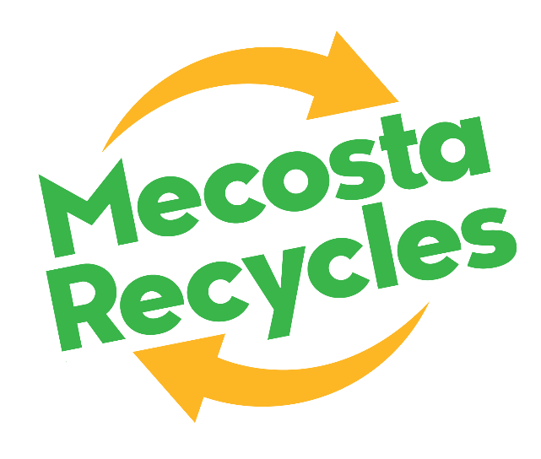

FOR IMMEDIATE RELEASE
November 13, 2024

Contact: Paul Griffith, 231.250.1173 or psaagriffith@gmail.com

You Bet Mecosta Recycles!
Recycling of Mecosta announces extensive rebranding initiative to reflect the organization’s efforts to boost community recycling superpowers.
BIG RAPIDS, Mich. — Recycle of Mecosta today announces it is rebranding to Mecosta Recycles, reflecting the organization’s ongoing efforts to promote local waste material recovery and recycling through its community-based recycling services. The rebranding, including a new name, new look, and new website, comes as millions nationwide celebrate National Recycling Day on November 15th.
“With National Recycling Day this week, we are excited to unveil our refreshed logo and a new and improved website Mecosta Recycles,” said Bonnie Clark, President of the Mecosta Recycles board of directors. “Since its founding more than 35 years ago, Recycle of Mecosta has grown and succeeded as a community-based, nonprofit organization committed to providing our area’s residents and businesses with the recycling services and resources needed to make recycling a priority by making it convenient. With Mecosta Recycles, our mission and message come through loud and clear.”

Elements of Mecosta Recycles brand evolution include:

New Name: Active, affirmative, committed, prideful – and dare we say, energized! Mecosta Recycles is our evolved new name, designed to motivate our community to take simple, yet powerful, actions that reduce waste, protect our environment, and contribute to our local economy. It tells our community and the world we love our community and planet, and we walk our talk when it comes to recycling.

New Brand Colors & Logo: Clean and green, that’s the way, Mecosta! Fresh and energizing, our new logo with its swooshy arrows is built around the traditional reduce, reuse, recycle logo everyone would recognize, but in our own modern interpretation that says, “this way forward.”

New Website – Mecostarecycles.com: Our new website is designed to empower area residents to take charge and become a team of recycling heroes for our planet and future generations. The easy-to-navigate site provides information on our services and hours, how to donate and volunteer, which items are recyclable and how to prepare them for recycling, and when and where to take them. Businesses and organizations can schedule pickups by contacting us via the website. We also have included links to other recycling, hazardous waste, and other special-handling waste drop-off resources at work throughout our community.

“None of us does anything alone, and Mecosta Recycles thanks our community’s superhero supporters, who have contributed in many ways to making the resources, volunteers, vehicles, and equipment that enable our operations that support resident and business recycling based on donations,” said Paul Griffith, Mecosta Recycles board member. “The generosity of our major supporters and everyday donors enables us to continue to grow our services and now our ability to communicate with those we serve in the most compelling and user-friendly ways.”
Recycle of Mecosta thanks its partners & sponsors:

- Big Rapids Charter Township
- Big Rapids Lions Club
- Big Rapids Public Schools
- Big Rapids Rotary
- Colfax Township
- Consumers Energy Foundation
- Ferris State University
- Gerber Construction
- Green Charter Township
- Hamtech Inc.
- Horizon Bank
- Ice Mountain Natural Spring Water
- Mecosta County
- Mecosta County Community Foundation
- Mecosta Township
- TC Energy

National Recycling Day recognized on the 15th of every November encourages people to reduce waste by purchasing recycled products, recycle to protect natural resources, promote environmental stewardship, and improve the quality of life. Here in Michigan, the recycling rate has hit an all-time high for the third consecutive year, putting Michigan on track to achieve the state’s 30% recycling goal by 2029.

About Mecosta Recycles
Caring for our Community, Natural Environment and Planet: Dedicated to caring for our community, natural environment and planet, we are a non-profit, volunteer-based organization that provides high-quality waste and disposal services. Our commitment to Mecosta County extends to building strong partnerships with other recycling entities to protect our environment and support our residents and businesses. https://mecostarecycles.com/

###

